Easy Invoice Pro
Small business owners spend a lot of time chasing money they are owed. They send invoices by hand, forget who paid and who did not, and lose track of expenses until tax season shows up and surprises them. I wanted to build something that fixes that, so I built Easy Invoice Pro.

What it actually is
It is a mobile app for Android phones. Think of it as a pocket accountant for a small business. A person running their own company, whether that is freelance design work, consulting, or a small shop, can use it to send professional looking invoices, track who has paid and who has not, log their expenses, and see how their business is doing financially, all from their phone.

What it does, explained simply
You can create an invoice for a customer and the app automatically gives it a proper invoice number, so nothing gets duplicated or messy. You can save your customers and the products or services you offer, so you are not retyping the same information every single time. The app tracks whether an invoice has been paid, partially paid, or is still outstanding, so you always know where you stand with every client. You can set up your own business profile, including your company logo, so every invoice looks like it came from a real, established business rather than a generic template. There is even support for a review QR code on receipts, so happy customers can quickly leave you a review. When it is time to actually get paid or keep records, the app can generate real PDF invoices, receipts, and financial reports, and you can print them or share them directly. It also breaks down your income by day, month, and year, and lets you track your expenses, so you get a full picture of your business finances in one place instead of spread across notebooks, texts, and memory.

Why I built it this way
I wanted this to feel like a real product a small business owner would actually want to use, not just a school style demo. That meant thinking through the small details that matter in real life, like automatic invoice numbering so nothing gets mixed up, or a review QR code that helps a small business actually grow, or proper financial reports instead of just a list of numbers. Every feature came from imagining an actual business owner opening the app and needing something specific to get their day done.

The technology behind it, in plain terms
The app is built for Android phones using Kotlin, which is the modern programming language Google recommends for Android development. The screens themselves are built with something called Jetpack Compose, which is a newer, more efficient way of building app interfaces directly in code. All of the data, meaning every invoice, customer, product, payment, and expense, is stored locally on the device using a system called Room, which sits on top of SQLite, the standard lightweight database built into every Android phone. In short, nothing here is a shortcut or a toy version. It is built the same way real, professional Android apps are built today.

Inside the home screen
The dashboard you read about above did not build itself. Below are two snippets straight from the file that powers it, showing the logic that calculates income and the layout that puts it all on screen.
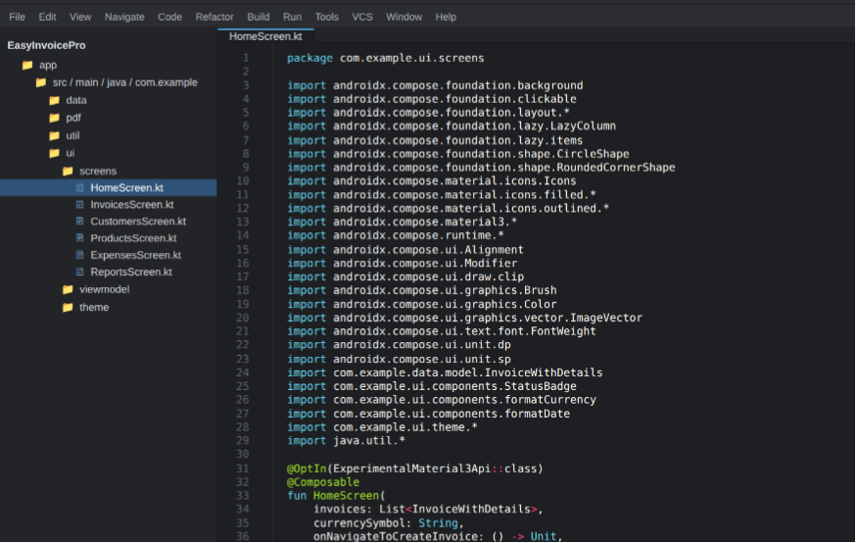
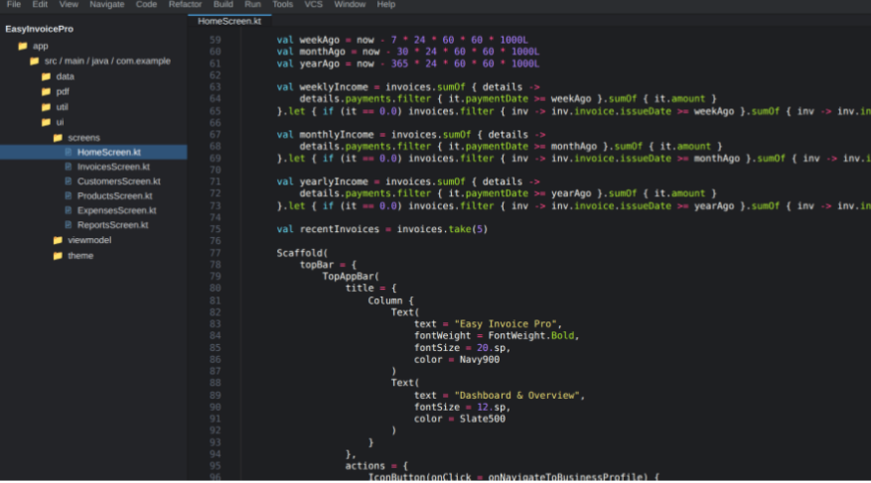

Getting it running
If someone wants to open this project and run it themselves, here is what that looks like in plain terms. First, they need Android Studio, which is the free program from Google used to build Android apps. Once that is installed, they open this project folder inside it, let the tool download anything it needs in the background, and then run the app on either a real Android phone connected to the computer or a virtual phone simulator built into Android Studio.

Before this goes out into the world
If this app were ever going to be published for real users to download, there are a few responsible things to double check first. That includes making sure the app is properly signed for release, having a real privacy policy in place since it stores customer information, reviewing any payment related features carefully, checking what permissions the app is asking for on someone's phone, and filling out Google Play's own data safety information honestly. None of that is optional once real people's data and money are involved.

Why this project matters
This project shows that I can take a real, practical problem that real people actually deal with and turn it into a working piece of software from start to finish. Not just the visible parts either. I designed how the data is structured behind the scenes, built the actual screens someone would tap through, and thought about what a business owner truly needs day to day. That is the kind of thinking I bring to any project I work on.

